**MOUNT LAWLEY SENIOR HIGH SCHOOL**

**YEAR 8 BIOLOGICAL SCIENCE END OF TOPIC ASSESSMENT 2022**

**MULTIPLE CHOICE QUESTIONS**

1. Which of the following is a body system?
2. A group of similar cells doing the same function.
3. A group of different tissues working together to perform a function.
4. A group of organs acting together to carry out a function.
5. A group of systems co-operating to ensure the survival of the individual.
6. Which is the longest, strongest bone in the human body?
7. Tibia
8. Humerus
9. Femur
10. Ulna
11. How many bones are in the average human body?
12. 206
13. 300
14. 126
15. 412
16. Which of the following correctly describes the axial and appendicular skeleton?
17. The axial skeleton is made up of central bones which protect vital organs while the appendicular skeleton is made up of our upper and lower limbs which allow for movement
18. The axial skeleton is made up of our upper and lower limbs which protect vital organs while the appendicular skeleton is made up of our central bones which allow for movement
19. The axial skeleton is made up of central bones which allow for movement while the appendicular skeleton is made up of our upper and lower limbs which protect vital organs
20. The axial skeleton is made up of our upper and lower limbs which allow for movement while the appendicular skeleton is made up of central bones which protect vital organs
21. What are the two forms of bone tissue?
22. Hard and soft
23. Spongy and cancellous
24. Spongy and compact
25. Cortical and compact
26. Diagram

    Description automatically generated Use the information in this diagram of the human heart to identify the correct  
     statement from the list below.
27. Blood travels to the lungs from 3 and returns into 9.
28. Blood travels to the body from 5 and returns into 6.
29. Blood travels to both lungs from 5 and returns to the heart through 2.
30. Blood travels to the body from 3 and returns to the heart through 2.

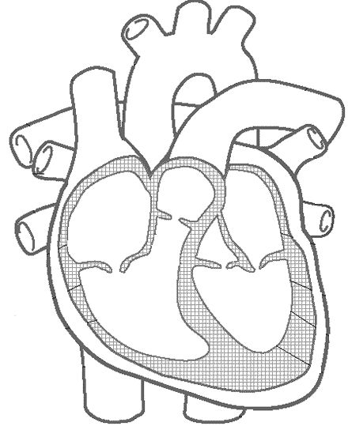

A

B

C

D

1. Choose the answer that correctly labels the heart diagram **from A🡪D**
2. Right Ventricle, Right Atrium, Left Ventricle, Left Atrium
3. Left Atrium, Left Ventricle, Right Atrium, Right Ventricle
4. Right Atrium, Right Ventricle, Left Atrium, Left Ventricle
5. Left Ventricle, Left Atrium, Right Ventricle, Right Atrium
6. What are capillaries?
7. The smallest blood vessels of the circulatory system.
8. The medical name for heart muscle cells.
9. Small lumps of fatty tissue that can clog blood vessels.
10. Cells that guard against infection
11. The circulatory system is composed of:
12. The heart, blood, and blood vessels.
13. The heart, the brain, and the lungs.
14. The lungs, the blood, and the blood vessels.
15. The brain, the heart, and the blood vessels.
16. What happens in the mouth during digestion?
17. Teeth break down food mechanically using enzymes.
18. Teeth break down food chemically, mixing saliva with the food for easier digestion.
19. Saliva breaks down food chemically using enzymes.
20. a and c.
21. Bile is made in the _____________ and stored in the ________________.
22. gall bladder, small intestine
23. liver, gall bladder
24. pancreas, small intestine
25. gall bladder, liver
26. Most of the absorption of nutrients occurs in the ______________.
27. stomach
28. small intestine
29. liver
30. large intestine
31. Peristalsis occurs in the digestive tract in:
32. the Oesophagus, small intestine, and large intestine only
33. the small and large intestines only
34. the stomach and small intestine only
35. from the pharynx to the rectum
36. Which selection includes only accessory organs that are part of the digestive system?
37. salivary glands, thyroid gland, pancreas, liver
38. stomach, duodenum, pancreas, gallbladder
39. gallbladder, liver, pancreas, salivary glands
40. liver, thyroid gland, gallbladder, spleen
41. Which of the following statements is NOT true?
42. Arteries – transport blood away from the heart.
43. Arteries – return blood from the tissue to the atria.
44. Capillaries – site of exchange of substances between blood and tissue fluid.
45. Veins – rely on muscle contraction to assist blood movement.
46. What is the function of the villi in the small intestine?
47. To decrease the amount of exposed surface.
48. To help spread the enzymes over a larger area.
49. To increase the surface area for absorption.
50. To sweep particles across the surface with wavelike actions.
51. Our throat divides into two separate tubes: one for the digestive system, the other for the respiratory system. What prevents food from entering the lungs?
52. The pharynx
53. The tongue
54. The trachea
55. The epiglottis
56. Which one of the following describes a vein?
57. It has thin walls and carries oxygenated blood away from the heart.
58. It has thick walls with valves and carries blood under pressure.
59. It has a very thin wall with valves and carries blood under pressure.
60. It has thin walls with valves, and carries blood to the heart
61. Which of the following lists respiratory structures from largest to smallest
62. Alveoli, bronchioles, bronchi
63. Bronchioles, bronchi, alveoli
64. Bronchi, bronchioles, alveoli
65. Bronchi, alveoli, bronchioles
66. Which of the following does not produce (make) digestive enzymes?
67. Pancreas
68. Salivary glands
69. Stomach
70. Liver
71. Gastric juices in the stomach:
72. Kill bacteria.
73. Work together to digest food.
74. Include hydrochloric acid.
75. All of the above.
76. Chemical digestion occurs in the;
77. Mouth, stomach and small intestine
78. Stomach, small intestine and large intestine
79. Stomach only.
80. Mouth, stomach, small intestine and large intestine
81. Each time the heart beats, a pulse can be felt in;
82. A vein.
83. A capillary.
84. An artery.
85. An aorta.
86. This graph shows that the breathing rate increases when you start exercising but that it does not necessarily continue to increase as you continue to exercise.

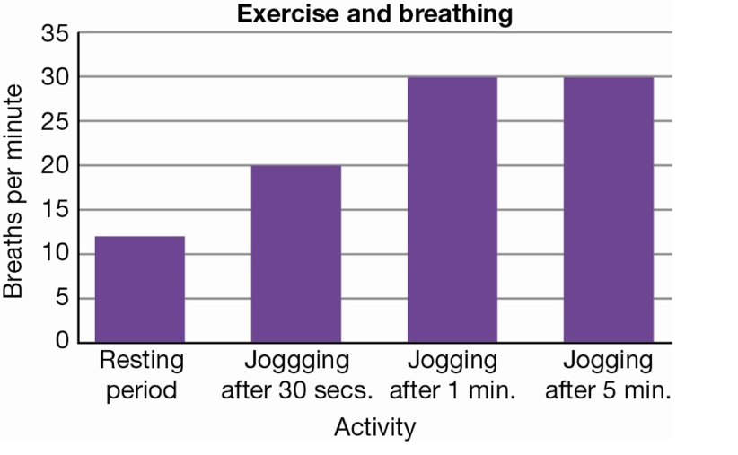

Identify the statement that *cannot* explain the data in the graph.

1. As you start to exercise, your breathing rate increases because you need more oxygen for your muscles to work.
2. Physical activity produces more carbon dioxide in your body and you have to get rid of it.
3. When you do a lot of exercise you breathe more deeply and you do not have to breathe as often.
4. When you are exercising at a constant rate your breathing rate becomes constant.
5. When you breath in, your diaphragm;
6. Contracts and is dome shaped
7. Contracts and is flattened
8. Relaxes and is dome shaped
9. Relaxes and is flattened

**End of Multiple Choice.**

**Please move on to the Short Answer Section.**

|  |  |
| --- | --- |
| Mount Lawley Senior High School - Wikipedia | **Mount Lawley Senior High School** |
| **Year 8 2022 – Biological Science – End of Unit Test: Body Systems** |
| Name: ___________________________________________________________  Class: _____________________________ Date:_____________________ |

***Section A: Multiple Choice – Please shade the best suited answer* 25 marks**

1. A B C D
2. A B C D
3. A B C D
4. A B C D
5. A B C D
6. A B C D
7. A B C D
8. A B C D
9. A B C D
10. A B C D
11. A B C D
12. A B C D
13. A B C D
14. A B C D
15. A B C D
16. A B C D
17. A B C D
18. A B C D
19. A B C D
20. A B C D
21. A B C D
22. A B C D
23. A B C D
24. A B C D
25. A B C D

**Multiple Choice: ________ /25**

**Short Answer: ________ / 30**

**TOTAL: ________ / 55**

***Section B: Short Answers – Please write your answers in the space provided***

1. *The human circulatory system is referred to as a double system*

a. Describe the difference between the blood that is pumped to the lungs and the blood that is pumped to the rest of the body. *(Think in terms of the types of gases in the blood)* (2 marks)

Blood to lungs is low in oxygen & high in carbon dioxide (Deoxygenated) (1)

Blood to body is high in oxygen and low in carbon dioxide (Oxygenated) (1)

_____________________________________________________________________________________

_____________________________________________________________________________________

_____________________________________________________________________________________

b. Explainwhat is meant by a double system. (2 marks)

There are two separate circuits through which the blood flows.

Blood goes to lungs (1) Blood goes to the rest of the body (1)

Double system does **not** refer to having deoxygenated and oxygenated blood.

_____________________________________________________________________________________

_____________________________________________________________________________________

1. Complete the following diagram **outlining** the movement of blood through the heart. (6 marks)

**One mark per correct answer.**

Right Atrium

Tricuspid Valve

Pulmonary Valve

Left Atrium

Left Ventricle

Aortic Valve

Bicuspid Valve

Right Ventricle

1. **Describe** how the structure of arteries relate to their function in the circulatory system (3 marks)

____________________________________________________________________________________________________________________________________________________________________________________________________________________________________________________________________________________________________________________________________________________

Arteries take **high pressure blood** away from the heart – 1 mark

Arteries have **thick walls** of **muscular and elastic tissue** – 1 mark

To **withstand the pressure** by **contract/bounce back** into shape – 1 mark

OR to **push the blood forward under pressure**

They do NOT pump the blood

1. Match the components of blood with their function in the circulatory system (4 marks)

**Component Number Function**

**4**

Plasma 1. Fights infections

**2**

Platelets 2. Assists in clotting blood

**1**

White Blood Cells 3. Carries oxygen around the body

**3**

Red Blood Cells 4. Supports cells and carries nutrients including hormones and wastes

1. **Diagram

   Description automatically generated** Label the organs of the digestive system. (4 marks) **HALF MARK PER CORRECT LABEL.**

Small Intestine OR ileum

Stomach

Liver

Oesophagus

Large Intestine

Pancreas

Anus

I would also accept Rectum

Mouth/Oral Cavity

1. **Outline** the difference between mechanical and chemical digestion (2 marks)

________________________________________________________________________________________________________________________________________________________________________________________________________________________________________________________________________________________________________________________________________

Mechanical digestion is when food is **broken into smaller pieces** and no new substances are made – 1 mark

Chemical digestion is when complex **molecules are broken down into smaller/simpler molecules** which the body can absorb – 1 mark

1. **Identify** organs labelled A-F in the respiratory system (3 marks)

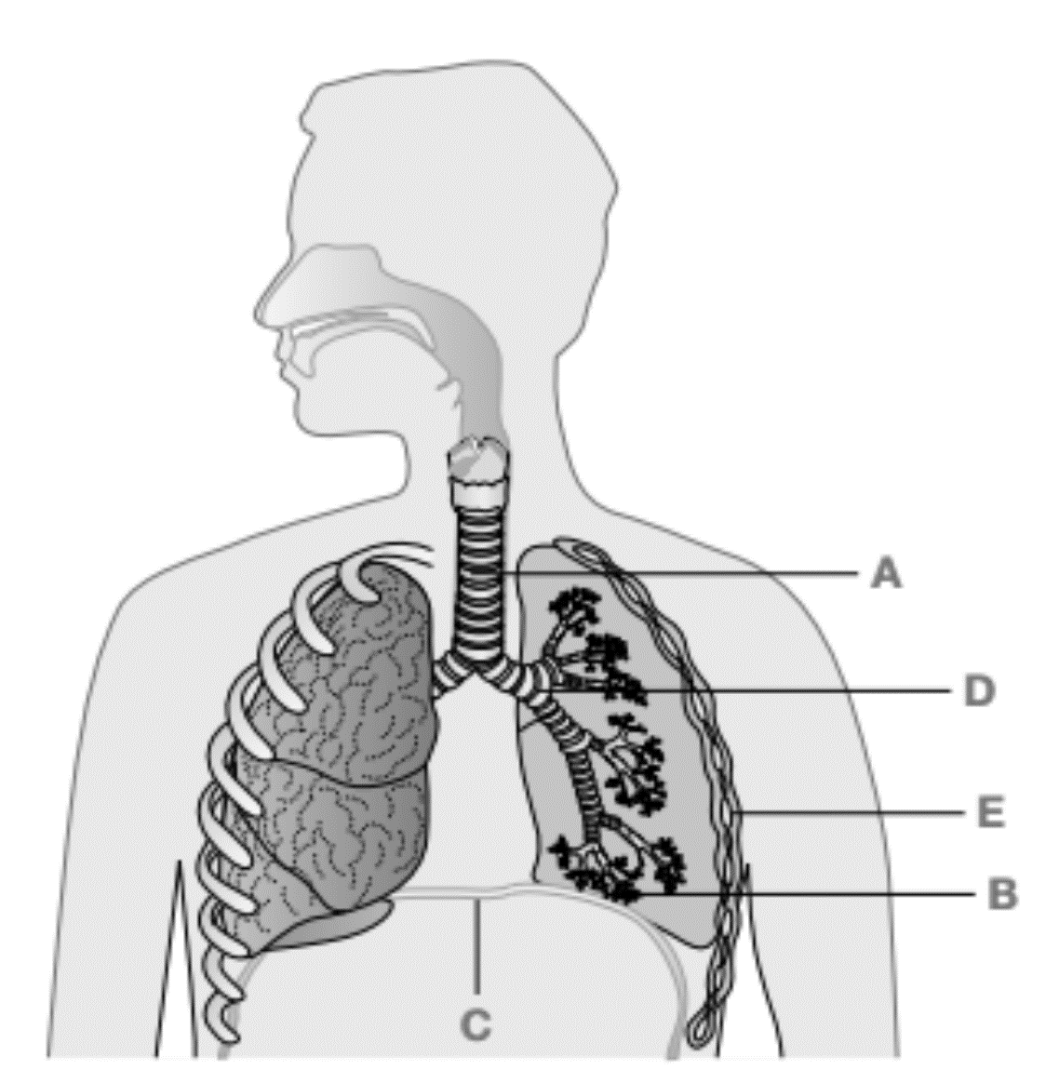

**F**

**A**

**D**

**E**

**C**

**B**

Trachea

A:__________________________________

Rib (Intercostal Muscle / Ribcage)

Pharynx

Alveoli

E:__________________________________

F:__________________________________

B:__________________________________

Diaphragm

C:__________________________________

Bronchi / Left Bronchus

D:__________________________________

1. **State** the gas content in the blood at 1 and 4 and how the gas content **changes** at 2 and 3 (4 marks)

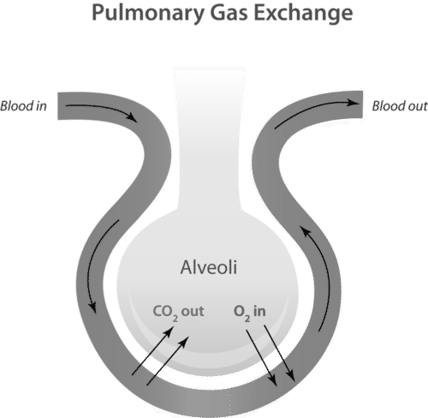

**2**

**3**

**1**

**4**

From the heart

Towards the heart

|  |  |
| --- | --- |
| 1 | Blood is **oxygen poor** and **carbon dioxide rich OR Deoxygenated** GAS CONTENT! |
| 2 | **Carbon dioxide** diffuses **from the blood into the alveoli** write full description! |
| 3 | **Oxygen** diffuses from the **alveoli into the blood** |
| 4 | Blood is **oxygen rich** and **carbon dioxide poor OR Oxygenated** |

**End of Test**